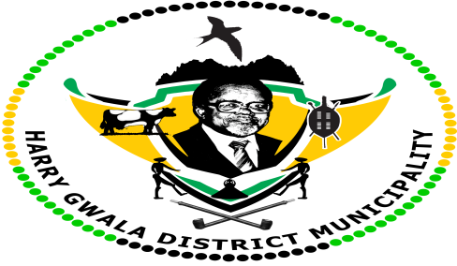
HARRY GWALA DISTICT MUNICIPALITY
“Together We Deliver and Grow”
SOCIAL SERVICES AND DEVELOPMENT PLANNING DEPARTMENT
40 Main Street, P/Bag X501, Ixopo, 3276
Tel: 039-834 8700 Fax: (039) 834 1701
E-mail: mahlabat@harrygwaladm.gov.za
MUNICIPAL HEALTH SERVICES
Regulation 3(1)
APPLICATION FOR A CERTIFICATE OF ACCEPTABILITY FOR A MILKING SHED

Regulation 3 (1) of Government Notice GNR 961 OF 23 NOVEMBER 2012. Regulations Relating to Hygiene Requirements for Milking Sheds, The Transport Of Milk And Related Matters promulgated in terms of the Foodstuffs, Cosmetics and Disinfectants Act, 1972 (Act No. 54 of 1972)
Surname of Applicant:
Names of Applicant:
Physical address:
GPS coordinates:
Postal address:
Business telephone number:
Cellphone number:
E-mail address:
Description of premises:
(As stipulated on the Title Deed
Number of personnel employed:
Maximum number of milk animals milked:
Type of water supply source:
Electricity Supply (Y/N):
Name of Holder or Manager:

Date of application: _________________

Signature of person in charge: ___________________________

Name and Surname of Environmental Health Practitioner received the application:

___________________________________________

Date received ________________

Signature: ____________________

